


Université Claude Bernard Lyon 1
BSc in Bioinformatics — Portail Informatique
UE LIFSTAGE — Third Year Internship Report

Developing Python based pipeline for Alternative Splicing Analysis of Mouse Transcriptome in Circadian Context

Student:
Gricey Rangel Trejo
BSc in Bioinformatics, 3rd year
Internship period: April 27 to August 28, 2026
Institut de Genomique Fonctionnelle de Lyon (IGFL)
Ecole Normale Superieure de Lyon — CNRS UMR 5242, Lyon, France
Internship supervisor:
Dr. Kiran Padmanabhan
Research Director and Group Leader, IGFL / Directeur de Recherche, INSERM
Academic tutor:
M. Alexandre Meyer
Universite Claude Bernard Lyon 1
Academic year 2025-2026

1. Problem Statement and Objectives 3
2. Internship Conditions, Host Institution, and Research Team 3
2.1 Institut de Genomique Fonctionnelle de Lyon (IGFL) 3
2.2 The Padmanabhan Research Group 3
2.3 Internship Conditions and Team 4
3. Scientific and Technical Background 4
3.1 Splicing basics and SUPPA event types 4
3.2 Key tools 6
3.3 Two sequencing technologies: Nanopore and Illumina 6
4. Research Work and Results 7
4.1 Software and tools 7
4.2 Repository structure and workflow overview 7
5. Project 1: Exploring the Effect of the SUPPA Boundary Parameter 8
5.1 Context and objective 8
5.2 Data and pipeline setup 8
5.3 Results 10
5.3.1 Variable mode detects substantially more events 10
5.3.2 Variable mode is a superset of strict mode 10
5.3.3 Gene-level perspective: novel genes and novel transcripts 11
5.3.4 PSI values are consistent between modes for shared events 12
5.3.5 Significant differential splicing events 12
5.4 Case study: gene C8g (ENSMUSG00000015083) 13
5.5 Summary 13
6. Project 2: Orthogonal Validation of Nanopore Alternative Splicing with Illumina Short-Read RNA-seq 13
6.1 Objective 13
6.2 Data 13
6.3 Pipeline 13
6.5 Current status and plan for July-August 15
7. Conclusion 16
7.1 Link to my degree and skills developed 16
7.2 What this internship taught me 16
7.3 Perspectives 16
Code Availability 18
References 18
Annexes 19

1. Problem Statement and Objectives
This report describes a research internship carried out at the Institut de Génomique Fonctionnelle de Lyon (IGFL), ENS Lyon, from April 27 to August 28, 2026, under the supervision of Dr. Kiran Padmanabhan (Research Director and Group Leader).

Alternative splicing, the mechanism by which a single gene produces multiple distinct RNA molecules ("RNA versions"), each potentially encoding a different protein, is widely recognized as a driver of disease: mutations affecting the splicing machinery are found in certain cancers, and splicing defects underlie neurological conditions such as spinal muscular atrophy (Gehring and Roignant, 2021).

This lab studies how the circadian clock (the body's internal 24-hour timer) controls gene activity, with one research line focused on the liver, and specially on alternative splicing, which is the focus of this internship. Within this context, the internship was structured around two sequential projects, with additional projects to be added if time allows:

Project 1 explored how a key parameter of SUPPA (a tool that detects and quantifies alternative splicing events, i.e. specific instances of exon/intron variation between RNA versions, see Section 4.1) affects event detection (Figures 6-12). It showed that relaxing this parameter by 1 nucleotide (nt) produces a superset of the stricter-setting's events, that 1nt is the meaningful inflection point, and that both settings produce consistent PSI (Percent Spliced In) values for shared events.

Project 2, carried out during the remaining internship period, validates the lab's Nanopore-based splicing findings using public Illumina short-read RNA-seq data (Aviram et al., 2021), as requested by manuscript reviewers (Figure 13).

At the time of writing, Project 1 is complete and Project 2 is in preparation.

2. Internship Conditions, Host Institution, and Research Team

2.1 Institut de Genomique Fonctionnelle de Lyon (IGFL)
The Institut de Génomique Fonctionnelle de Lyon (IGFL) is a joint research unit (UMR 5242) affiliated with the CNRS, the École Normale Supérieure de Lyon (ENS Lyon), and the Université Claude Bernard Lyon 1. Located on the ENS Lyon campus in Lyon, France, it brings together research groups working on genomics, developmental biology, and evolutionary biology, with a shared interest in understanding how genes are regulated and what happens when that regulation changes.
The institute supports both experimental and computational research, with access to high-throughput sequencing, proteomics, and imaging platforms, making it well suited for interdisciplinary projects that combine wet-lab biology with bioinformatics.

2.2 The Padmanabhan Research Group
A key focus is the relationship between the clock and RNA processing: not just which genes are turned on or off, but which transcript isoforms (“RNA versions”) are produced and how the clock shapes that choice over time. This includes alternative splicing, chromatin organization, and the role of specific regulatory factors connecting the two.

The data used in this project comes from mouse liver RNA, sequenced using Oxford Nanopore long-read sequencing in collaboration with Prof. Yutaka Suzuki's group (University of Tokyo). Three experimental conditions were sampled, each with 3 biological replicates: wild-type mice (WT) at two circadian times (CT8 and CT20), and Per1/Per2 double-knockout mice (PerKO), a mutant line with a disrupted circadian clock, at CT20 (Table 1, Annex A). Project 2 uses a different experimental design, detailed in its corresponding annex (Annex E).

Condition | Genotype | Circadian Time (CT) | Replicates
WT CT8 | Wild-Type | CT8 | 3
WT CT20 | Wild-Type | CT8 | 3
PerKO CT20 | Per1/Per2 KO | CT20 | 3
Table 1. Experimental design for Project 1: three conditions, each with 3 biological replicates.

2.3 Internship Conditions and Team
The internship was carried out within a small research team, with day-to-day supervision provided by Khushi Mamgain (PhD student and co-first author of the manuscript under review). Work was organized around weekly presentations to Dr. Kiran Padmanabhan, in which results and methodology were discussed and next steps defined. Both projects were built on an existing codebase developed by previous contributors, Lies Chikhaoui (PhD thesis, 2022) and Dr. Bharath Ananthasubramaniam (collaborating computational biologist, Berlin), requiring careful reading of prior work before any new analysis could begin. Project 1 was carried out in close collaboration with Khushi, while Project 2 requires more independent work. Wet-lab context was provided by Constanza Blanco. The computational work was done on a laboratory-provided Mac workstation using Bash and Python, with version control on GitHub.

3. Scientific and Technical Background

3.1 Splicing basics and SUPPA event types
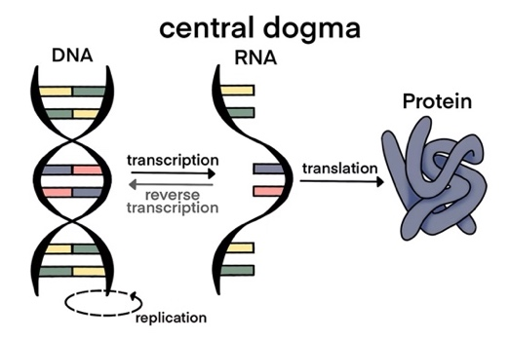
DNA carries the genetic code in every cell of our body, written as a sequence of four chemical letters called nucleotides (nt). Specific sections of DNA called genes contain the instructions for building proteins (the molecules that do most of the work in a cell). To build a protein, the cell first copies a gene into a molecule called messenger RNA (mRNA) (this is called transcription). The mRNA is then used to assemble the protein (this is called translation).

Figure 1. The central dogma of molecular biology. Wellcome Connecting Science. Retrieved from YourGenome (https://www.yourgenome.org/theme/how-is-dna-turned-into-protein-the-central-dogma-of-molecular-biology/).
However, the mRNA isn't ready to use straight away. The initial copy, called pre-mRNA, contains sections that don't code for anything: introns. The functional sections are called exons. Before translation, the cell removes the introns and joins the exons together, a process called splicing, producing the final mature mRNA.
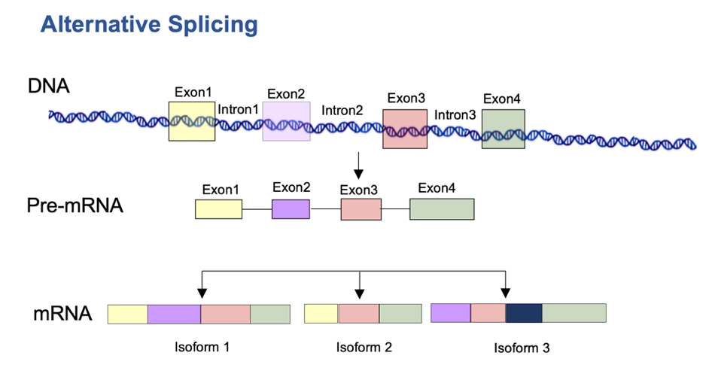
Splicing is not always done the same way. The cell can choose to include or skip certain exons, producing different mRNA versions (isoforms) from the same gene. This is called “Alternative Splicing".

Figure 2. Mamgain, (2026). Alternative Splicing.
More than 90% of human genes are alternatively spliced (Gehring and Roignant, 2021), making it one of the main mechanisms by which a genome generates a large diversity of functional products. Understanding which version of a gene product is made, when, and in response to what, is one of the central questions of modern biology. And a little section of all this, is what we studied here in this internship.
SUPPA (Trincado et al., 2018) is the tool used throughout both projects to detect, quantify, and compare these alternative splicing events. It provides several commands covering this workflow, from cataloging events in a reference annotation to computing per-sample PSI values and testing for significant differences between conditions; one of these commands, and a parameter within it, is the focus of Project 1 (Section 5)
SUPPA detects and quantifies seven types of alternative splicing events (Trincado et al., 2018):
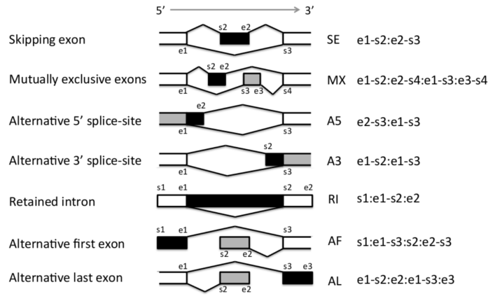
Figure 3. The seven alternative splicing event types defined by SUPPA. Adapted from Trincado et al., 2018 / SUPPA GitHub repository (github.com/comprna/SUPPA).
SE (skipped exon): an exon is present in one isoform and absent in the other.
RI (retained intron): an intron that is normally removed stays in the mature mRNA.
A3 (alternative 3' splice site): the 3' boundary of an intron is shifted, producing a longer or shorter exon.
A5 (alternative 5' splice site): same as A3 but at the 5' end of the intron.
MX (mutually exclusive exons): two exons exist, but only one appears per isoform.
AF (alternative first exon): the first exon differs between isoforms.
AL (alternative last exon): the last exon differs between isoforms.
Note that event coordinates are strand-dependent (Annex G shows the equivalent diagrams for both strands).
This project focuses on three (A3, A5, and RI), the event types most sensitive to the boundary parameter explored in Project 1; the other four (SE, MX, AF, AL) were detected but showed no sensitivity to this parameter (see section 6.3.1).
The core metric used throughout is PSI (Percent Spliced In), the proportion of transcripts including a given event (0 to 1); dPSI is the difference in PSI between two conditions.

3.2 Key tools
SUPPA is the main splicing analysis tool used in both projects (Trincado et al., 2018), already established in the laboratory's workflow (Chikhaoui, Mamgain et al., unpublished). Given a reference transcriptome (GTF file), SUPPA catalogs all possible alternative splicing events, computes PSI values from transcript expression estimates, and runs "diffSplice" to identify significantly different events between conditions (see Annex H). The reference used is a custom GTF derived from the lab's Nanopore data, built on GRCm39 (mm39), containing both annotated and novel isoforms (Chikhaoui, Mamgain et al., unpublished).
Salmon is a transcript quantification tool (Patro et al., 2017) that estimates transcript expression in TPM from RNA-seq reads using lightweight alignment. Its output feeds directly into SUPPA for PSI computation.
IGV (Integrative Genomics Viewer) is a genome browser (Robinson et al., 2011) used to visually inspect splicing events at specific locations in the genome, verifying that transcript structures detected by SUPPA were consistent with the underlying read data.
Bash was used for all pipeline automation, orchestrating multi-step tools on large data files.
Python was used for all data analysis and visualization in Jupyter notebooks. Python was chosen deliberately over R (more common in bioinformatics) as an opportunity to apply a language from the CS curriculum to a biological problem.
Beyond SUPPA, Salmon, and IGV, all downstream analysis like PSI tables, event filtering, and figure generation, was implemented in Python (pandas, matplotlib, matplotlib-venn) within Jupyter notebooks. This included applying statistical concepts from my Statistics and Biostatistics coursework: choosing between mean and median for summarizing PSI distributions, generating density and box plots, computing and interpreting p-values for differential splicing significance, and understanding normalization (DESeq2/limma) in the Project 2 pipeline.

3.3 Two sequencing technologies: Nanopore and Illumina
Both projects use transcriptome (RNA sequencing “RNA-seq”) data from two different sequencing platforms.
 | Nanopore (long-read) | Illumina (short-read)
Read length | Up to ~50,000 nt | ~150 nt
Output | Full-length isoforms | Short fragments
Isoform detection | Direct, unambiguous | Inferred from fragments
Sequencing depth | Lower | Higher
Error rate | Higher (raw reads) | Lower
Use in this project | Primary splicing data (Project 1) | Orthogonal validation (Project 2)
Table 2. Comparison of Nanopore long-read and Illumina short-read RNA-seq.

Nanopore long-read sequencing reads entire RNA molecules end-to-end, directly revealing which exons co-exist in a single transcript. Illumina short-read sequencing produces shorter fragments that must be computationally reassembled, but is deeper and more widely available (Table 2; Annex B). Benchmarking studies have shown long-read data improves transcript-level resolution compared to short reads (Chen et al., 2021). If Nanopore-detected splicing events are also detectable in independent Illumina data, this is strong evidence the findings reflect real biology rather than sequencing artifacts, the goal of Project 2.

4. Research Work and Results

4.1 Software and tools
The table below summarizes the main tools and languages used throughout the internship.

Tool / Language | Version | Role in the project
SUPPA2 | v2.3 | Alternative splicing event detection and PSI quantification
Salmon | v1.5.2 | Transcript expression quantification (TPM)
IGV | v2.19.7 | Genome browser for visual inspection of splicing events
Python | 3.8.20 (suppa_env) | Data analysis, filtering, and figure generation
pandas | latest in suppa_env | Tabular data manipulation
matplotlib | latest in suppa_env | Figure generation
matplotlib-venn | latest in suppa_env | Venn diagram visualizations
Bash / zsh | macOS zsh | Pipeline automation and file processing
GitHub | git | Version control and code repository (griceyrt/Internship)
VSCode | latest | Development environment for notebooks and scripts
Notion | web | Lab notebook, biology glossary, daily logs
Table 3. Software and tools used in the internship.
All bioinformatics tools were run inside a dedicated Python virtual environment (suppa_env, Python 3.8.20) to ensure reproducibility and avoid dependency conflicts.

4.2 Repository structure and workflow overview
All code produced during the internship is tracked in a public GitHub repository (Annex C).

The general computational workflow that was done in this Internship follows three stages:

- First, Bash scripts handle the heavy lifting: running SUPPA "generateEvents" to catalog all splicing events from the reference, running "psiPerEvent" to compute PSI values from Salmon TPM (Transcripts Per Million) outputs, and running "diffSplice" to compare conditions.
- Second, Python notebooks handle filtering, comparison, and visualization: loading SUPPA outputs into pandas dataframes, computing set operations between event populations, and generating figures with matplotlib.
- Third, IGV is used manually to inspect candidate events, verify transcript structures, and produce screenshots for reporting.

This separation between pipeline execution (Bash) and analysis (Python) kept the workflow modular, with each stage producing clearly named outputs that feed into the next.

5. Project 1: Exploring the Effect of the SUPPA Boundary Parameter

5.1 Context and objective
SUPPA's "generateEvents" module catalogs all possible alternative splicing events from a reference transcriptome. One of its key parameters is the boundary mode, which determines how precisely a splice site must match the annotated coordinates in the reference in order to be detected. In strict mode (the default, and the mode used in the manuscript), splice sites must match exactly. In variable mode, a tolerance of N nucleotides is allowed on either side, meaning that events with splice sites slightly offset from the annotation are still detected. This tolerance window is illustrated for each event type in Annex G.
The question explored in this project is: what happens when you change this parameter? Does relaxing the boundary at the very beginning of the pipeline lead to a meaningfully different set of detected events downstream?

5.2 Data and pipeline setup
The analysis used 9 samples from the laboratory's Nanopore RNA-seq dataset, covering three conditions with 3 biological replicates each (Table 4; see Annex A). The reference annotation used was transcriptome_productivity.gtf, the laboratory's custom GTF file built on GRCm39 (mm39). Transcript expression values (TPM) were pre-computed with Salmon by Khushi and provided as input.

Sample | Condition | Biological meaning
KM1, KM2, KM3 | CT8 | WT day
KM4, KM5, KM6 | CT20 | WT night
KM7, KM8, KM9 | PerKO | Clock disrupted
Table 4. The 9 Nanopore RNA-seq samples used in Project 1.
The workflow (see Figure 4) follows the approach established in SUPPA’s documentation (See Annex H) and Khushi’s guidance. "generateEvents" command identifies events from the rebuilt mouse transcriptome, PSI values are computed directly from the Salmon TPM expression values using "psiPerEvent", and "diffSplice" identifies differential splicing, with events at p < 0.05 and dPSI > 0.1 considered significant. "generateEvents" was run six times: once in strict mode, and five times in variable mode with tolerances of 1, 3, 5, 10, and 20 nucleotides, automated through run_suppa.sh

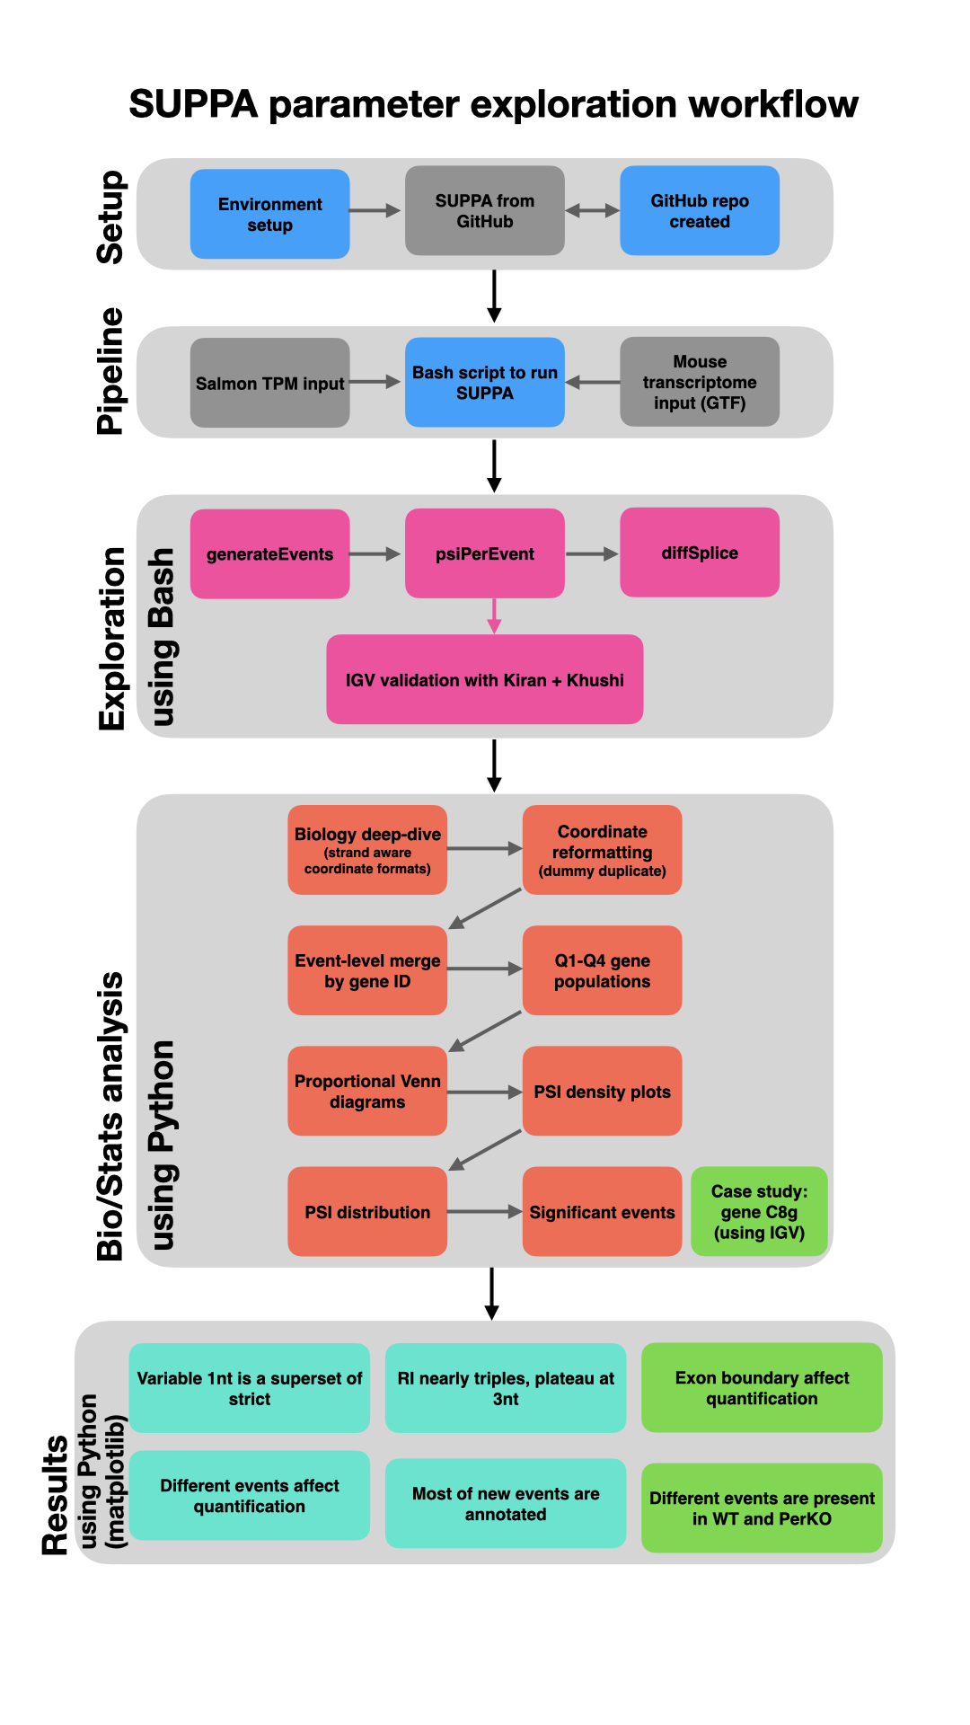
Figure 4. Project 1 workflow.

5.3 Results

5.3.1 Variable mode detects substantially more events
Switching from strict to variable 1nt mode increases the number of detected events for A3, A5, and RI. SE, MX, AF and AL counts remain identical across all boundary modes, confirming that the change is specific to events defined by a splice site boundary.
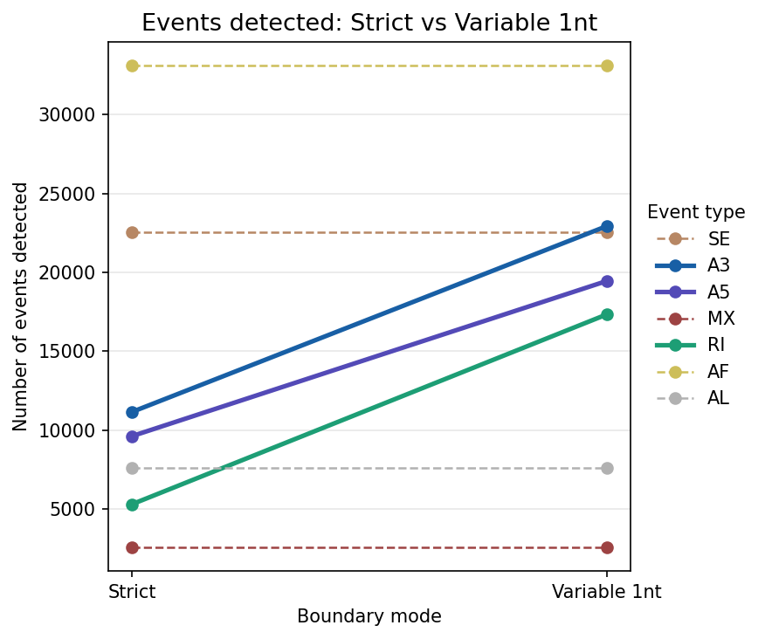
Figure 6. Event counts for each event type in strict vs variable 1nt mode. A3 increases from 11,164 to 22,932, A5 from 9,630 to 19,456, and RI from 5,316 to 17,337. SE, MX, AF and AL are unchanged.
When extended to all six boundary modes, counts for A3, A5, and RI increase from strict to variable 1nt, then plateau from 1nt onward. This plateau indicates that variable 1nt captures essentially the same set of events as any larger tolerance, making it the natural comparison point.
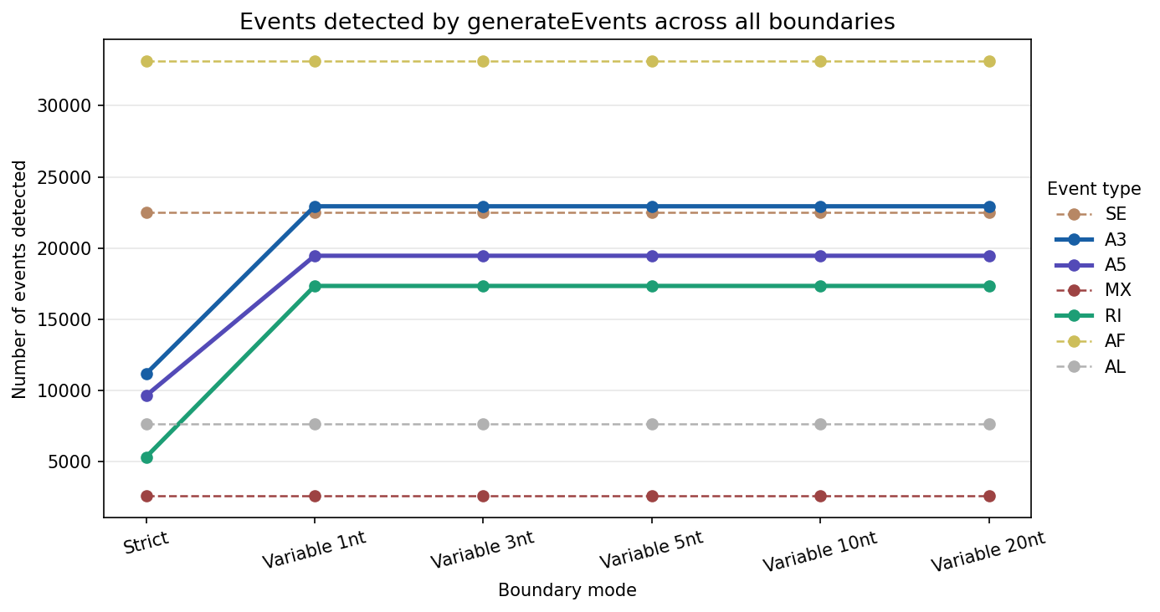
Figure 7. Event counts across all six boundary modes (strict, and variable 1nt, 3nt, 5nt, 10nt, 20nt). Counts plateau after 1nt for A3, A5, and RI.

5.3.2 Variable mode is a superset of strict mode
Events detected by strict mode were compared to those detected by variable 1nt mode. This required a coordinate reformatting step (dummy file), as strict and variable modes use different internal representations for the same event types. A strand-aware reformatting function was implemented in Python to make the IDs comparable.
After reformatting, all strict events were found within the variable event set, with zero exceptions across all three event types. This is expected and serves as a computational sanity check: relaxing a constraint can only add events, never remove them. Variable mode is therefore a true superset of strict mode.
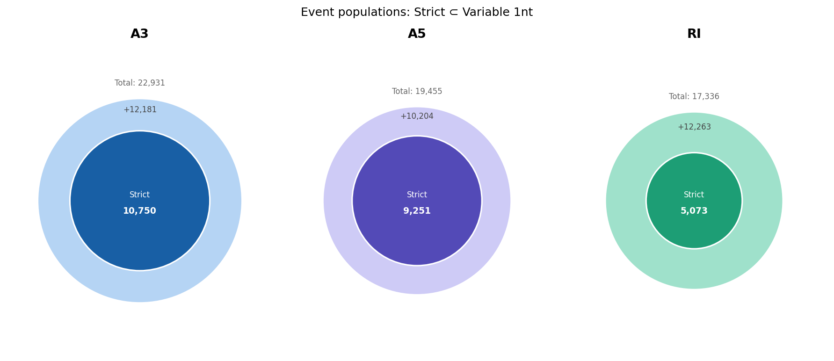

Figure 8. Strict mode events (inner) are fully contained within variable 1nt mode events (outer), confirmed for A3, A5, and RI.

5.3.3 Gene-level perspective: novel genes and novel transcripts
Variable 1nt mode detects events in thousands of genes that strict mode misses entirely, with a subset involving novel (unannotated) transcripts i.e. transcripts that are present in the data but have not yet been formally annotated in reference databases. (see Figure 9 and 10).
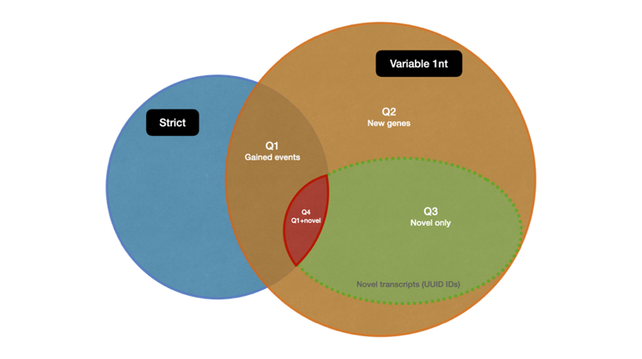
Figure 9. Gene populations defined by comparing strict and variable 1nt mode. Q1: genes gaining new events in variable mode; Q2: genes detected only in variable mode; Q3: variable-only events from novel (UUID) transcripts; Q4: subset of Q1 involving novel transcripts.
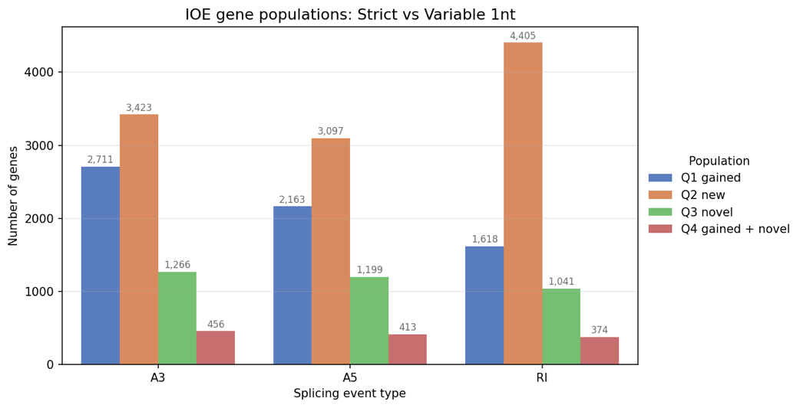

Figure 10. Gene counts per population (Q1–Q4) for A3, A5, and RI.

5.3.4 PSI values are consistent between modes for shared events
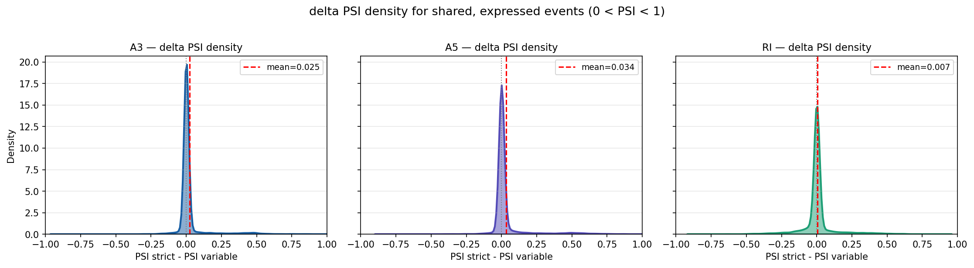
For events detected by both modes, a density plot of the PSI difference (dPSI = PSI_strict minus PSI_variable) shows a sharp peak at zero for all three event types, with mean dPSI values between 0.025 and 0.034. Both modes agree on the quantification of events they share.

Figure 11. Density plot of PSI difference for events shared between strict and variable 1nt mode. The peak at zero confirms quantification consistency for shared events across A3, A5, and RI.

5.3.5 Significant differential splicing events
After filtering (|dPSI| > 0.1, p < 0.05), strict mode yields 45 A3, 47 A5, and 13 RI significant events. Variable 1nt mode yields 73 A3, 76 A5, and 64 RI. Most strict significant events are also found in the variable significant set, confirming that variable mode is a superset at the level of statistically filtered results as well.
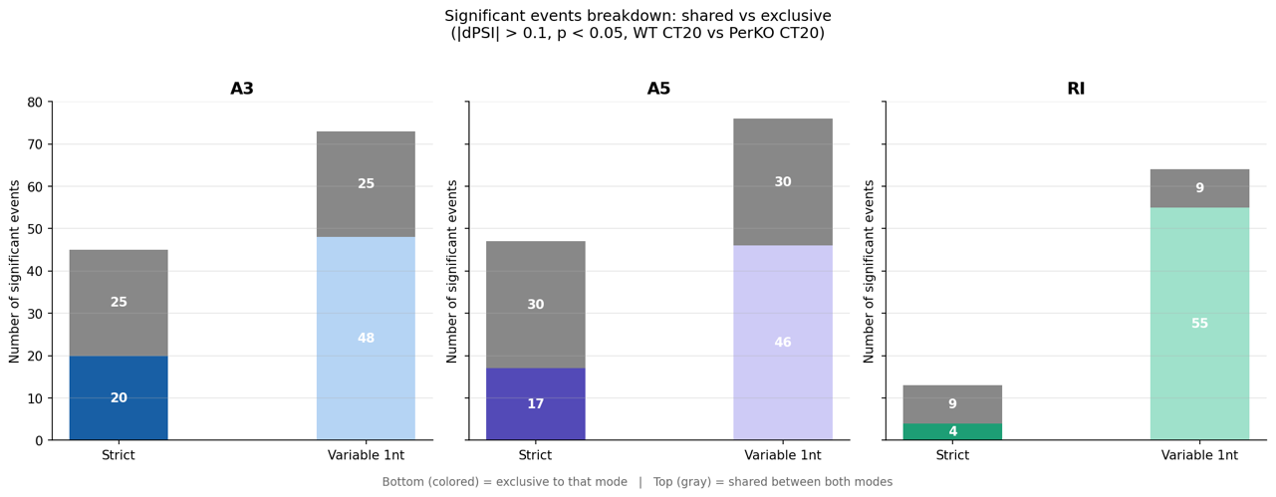
Figure 12. Significant differentially spliced events (|dPSI| > 0.1, p < 0.05) comparing WT CT20 vs PerKO CT20 in strict vs variable 1nt mode, for A3, A5, and RI.

5.4 Case study: gene C8g (ENSMUSG00000015083)
To illustrate the practical impact of the boundary parameter, one candidate event was examined in detail using IGV. Gene C8g shows an A3 event at chr2:25,389,127-25,389,517 with a dPSI of 0.952 between strict and variable mode in sample KM4 (PSI_strict = 0.977, PSI_variable = 0.025). This large discrepancy arises because variable mode detects a novel transcript (UUID identifier c765a871) at that locus that strict mode cannot see. The same locus also has a variable-only RI event driven by the same novel transcript. IGV inspection confirmed that the novel transcript is present in the read data and represents a structurally distinct isoform not captured by the standard annotation (see Annex D).

5.5 Summary
Variable 1nt mode is a true superset of strict at every level of the analysis, with the 1nt threshold as the meaningful inflection point. These findings informed the decision to use variable 1nt as the comparison parameter alongside the strict mode used in the manuscript.

6. Project 2: Orthogonal Validation of Nanopore Alternative Splicing with Illumina Short-Read RNA-seq

6.1 Objective
As part of the peer review process for Chikhaoui, Mamgain et al. (unpublished), reviewers requested an orthogonal validation of the Nanopore-based alternative splicing results using an independent sequencing technology. Project 2 reproduces the WT CT20 vs PerKO CT20 differential splicing comparison using public Illumina short-read RNA-seq data, using the lab's custom transcriptome, so that Nanopore-specific isoforms can be assessed for detectability in short-read data.

6.2 Data
Public dataset GSE171975 (Aviram et al., 2021): 7 samples selected (3 WT CT20, 3 PerDKO CT20, matched for replicate number), quantified against the lab's custom transcriptome FASTA (same reference as Project 1).

6.3 Pipeline
The pipeline is organized into four stages (see Annex E, Figure 13):

Stage 1: Setup (Bash)
- Environment setup: R packages (tximport, DESeq2, limma)
- Review of inherited scripts (Bharath’s SRA download/Salmon scripts, IGFL conventions)
- SRA download of the 7 FASTQ files
- Salmon alignment and quantification against the custom mouse transcriptome (FASTA)

Stage 2: Normalization (R)
- tximport: aggregates Salmon outputs into R
- DESeq2 normalization + limma batch correction = corrected expression matrix
- Critical formatting step: corrected values exported in SUPPA-compatible format (batch-corrected DESeq2 values, not raw Salmon TPM; no transcript_id header column)
Stage 3: PSI computation (SUPPA + Python)
- psiPerEvent: computes PSI values per event per sample, using the IOE catalogue (variable 1nt mode, inherited from Project 1)
- diffSplice: compares WT CT20 vs PerDKO CT20 (run from within the output directory), significance threshold |dPSI| > 0.1, p < 0.05

Stage 4: Results (Python/matplotlib)
- Comparison of Illumina-derived differential splicing events against Project 1 (Nanopore) results
- Cross-check against the list of differentially spliced events reported in the manuscript
- Final figures (deliverable), following established visual conventions (color palette, event ordering A3/A5/RI)

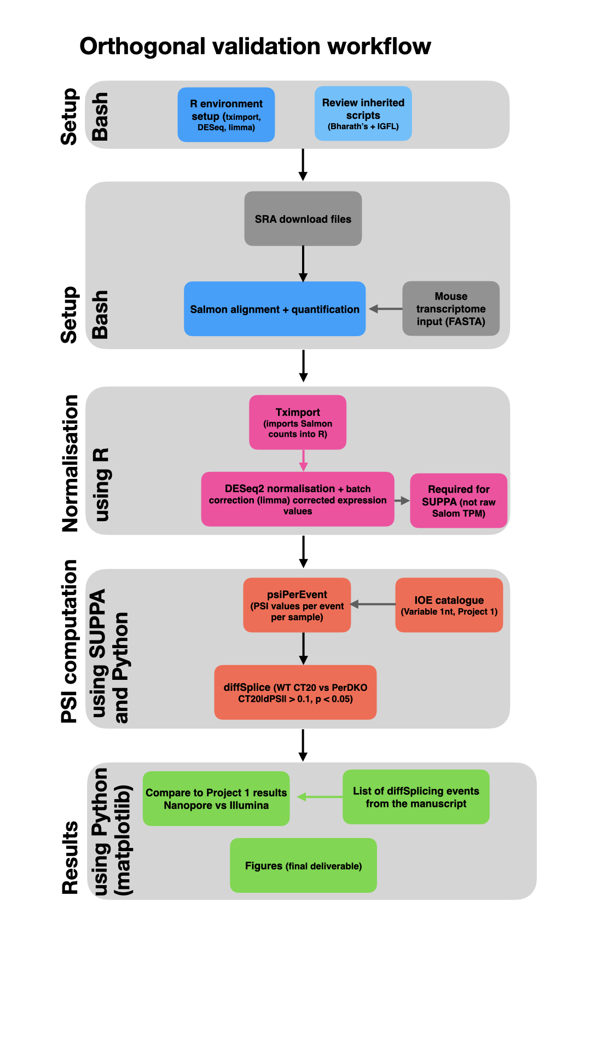
Figure 13. Project 2 workflow.

6.5 Current status and plan for July-August
At the time of writing, Project 1 has been completed and its findings presented to the research team. The pipeline for Project 2 has been mapped out, the data source confirmed, and the correct sequence of steps established following the clarifications of Khushi and Bharath.
Project 2 will be executed during mid-June and July (with a new project to cover the duration of my internship which is the end of August). The expected output is a set of figures showing the overlap between Nanopore-detected and Illumina-detected differentially spliced events, which will serve as the orthogonal validation requested by the manuscript reviewers.

7. Conclusion

7.1 Link to my degree and skills developed
This internship sits at the intersection of the two disciplines that define my BSc in Bioinformatics: computer science and biology. The computational work drew directly on programming skills, data structures, file system logic, and pipeline architecture. At the same time, it required developing a working understanding of molecular biology, RNA processing, and experimental design that goes well beyond what is covered in a CS curriculum. Navigating both simultaneously was the central challenge and also the central reward of the experience.
On the CS side, a concrete skill developed during the internship was the transition from GitLab (used at university) to GitHub for version control, including managing a public research repository, handling .gitignore conventions for large biological files, and maintaining a clean commit history that reflects the progression of the work. The choice to develop the analysis in Python rather than R, which is the more common language in bioinformatics, was deliberate: it was an opportunity to apply a language from the CS curriculum to a biological problem, and to demonstrate that the two approaches are more complementary than they are opposed.

7.2 What this internship taught me
On the technical side, this internship required building a working understanding of alternative splicing biology from the ground up. It became clear early on that research is not just about running code: reading papers carefully, understanding methodological choices made by others, and questioning assumptions rather than accepting outputs at face value are equally important parts of the work.
Beyond the biology, the internship developed a range of practical computational skills: building and debugging multi-step bioinformatics pipelines in Bash, analyzing and visualizing data in Python, working with real research-grade datasets that are messy and underdocumented, and navigating an inherited codebase built by multiple contributors with different approaches. Each of these required patience, initiative, and the willingness to go looking for answers independently.
Presenting findings through weekly Keynote presentations was one of the most formative parts of the experience. Preparing those presentations repeatedly exposed gaps in understanding and highlighted the importance of communicating across disciplines.
Attending seminars and lab events regularly, even when the topics were unfamiliar, was one of the best ways to pick up vocabulary and slowly get comfortable with a field that was completely new to me.
But perhaps what stayed with me most was the human side of research. Being part of a lab means being open to feedback, taking initiative to talk to people from different disciplines, asking questions out of genuine curiosity, and sharing your own progress even when it is incomplete. Research is a deeply collaborative and social activity, and that was something I did not fully appreciate before living it.

7.3 Perspectives
This internship confirmed the direction I want to take. In September 2026, I will begin a Master's degree in Life Sciences and Technologies (MSc LST) at the University of Lille, with the intention of specializing further in computational biology and bioinformatics. The experience of working on a real research project, contributing to a manuscript under review, and navigating the full lifecycle of a bioinformatics analysis, from raw data to figures to interpretation, has made clearer what a career in research actually looks like and why it is the right path.
My longer-term goal is to pursue a PhD in bioinformatics, building on the foundation established during this internship, and to keep working on the kinds of questions that motivated this project:
- how gene regulation shapes biological rhythms
- how computational tools can be used to detect and validate molecular events at scale
- how different data sources can be combined to build a more complete picture

Code Availability
The full pipeline, notebooks, and figures for this project are available in a public GitHub repository: github.com/griceyrt/Internship

References
Aviram, R., Dandavate, V., Manella, G., Golik, M., & Asher, G. (2021). Ultradian rhythms of AKT phosphorylation and gene expression emerge in the absence of the circadian clock components Per1 and Per2. PLOS Biology, 19(12), e3001492. https://doi.org/10.1371/journal.pbio.3001492
Chen, Y., Davidson, N. M., Wan, Y. K., et al. (2021). A systematic benchmark of Nanopore long read RNA sequencing for transcript level analysis in human cell lines. bioRxiv. https://doi.org/10.1101/2021.04.21.440736
Chikhaoui, L. (2022). Circadian regulation of post-transcriptional processes in the mouse liver [PhD thesis]. Ecole Normale Superieure de Lyon, Universite Claude Bernard Lyon 1.
Chikhaoui, L., Mamgain, K., Seki, M., Blanco, C., Sassolas, F., Folco, E. G., Sery, D., Suzuki, Y., Ananthasubramaniam, B., & Padmanabhan, K. (unpublished). PERIOD proteins dictate targeting of splicing factors to chromatin, shaping circadian transcriptome diversity. Manuscript under review.
Gehring, N. H., & Roignant, J.-Y. (2021). Anything but ordinary: emerging splicing mechanisms in eukaryotic gene regulation. Trends in Genetics, 37(4), 355-372. https://doi.org/10.1016/j.tig.2020.10.009
Love, M. I., Anders, S., Kim, V., & Huber, W. (2016). RNA-Seq workflow: gene-level exploratory analysis and differential expression. F1000Research, 4, 1070. https://doi.org/10.12688/f1000research.7035.2
Patro, R., Duggal, G., Love, M. I., Irizarry, R. A., & Kingsford, C. (2017). Salmon provides fast and bias-aware quantification of transcript expression. Nature Methods, 14(4), 417-419. https://doi.org/10.1038/nmeth.4197
Robinson, J. T., Thorvaldsdottir, H., Winckler, W., Guttman, M., Lander, E. S., Getz, G., & Mesirov, J. P. (2011). Integrative genomics viewer. Nature Biotechnology, 29(1), 24-26. https://doi.org/10.1038/nbt.1754
Sessegolo, C., Cruaud, C., Da Silva, C., Cologne, A., Dubarry, M., Derrien, T., Lacroix, V., & Aury, J.-M. (2019). Transcriptome profiling of mouse samples using nanopore sequencing of cDNA and RNA molecules. Scientific Reports, 9(1), 14908. https://doi.org/10.1038/s41598-019-51470-9
Soneson, C., Yao, Y., Bratus-Neuenschwander, A., Patrignani, A., Robinson, M. D., & Hussain, S. (2019). A comprehensive examination of Nanopore native RNA sequencing for characterization of complex transcriptomes. Nature Communications, 10(1), 3359. https://doi.org/10.1038/s41467-019-11272-z
Trincado, J. L., Entizne, J. C., Hysenaj, G., Singh, B., Skalic, M., Elliott, D. J., & Eyras, E. (2018). SUPPA2: fast, accurate, and uncertainty-aware differential splicing analysis across multiple conditions. Genome Biology, 19(1), 40. https://doi.org/10.1186/s13059-018-1415-7

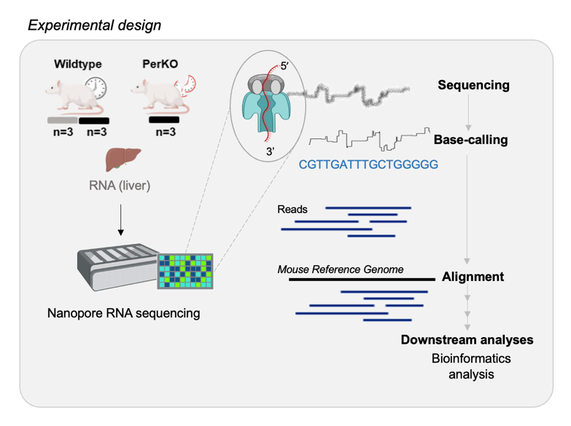
Annexes
A

Annex A. Experimental design. WT mice were sampled at CT8 and CT20; Per1/Per2 double-knockout mice (PerKO) were sampled at CT20. Three conditions, three biological replicates each.

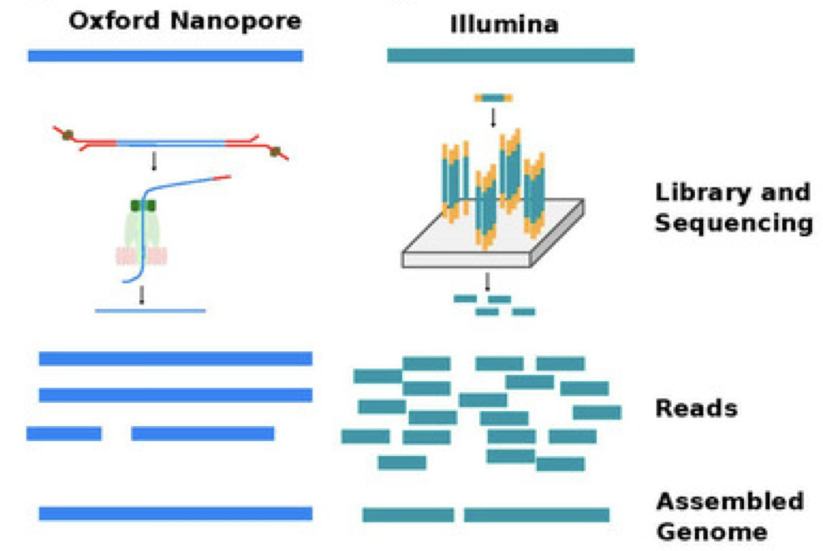
B

Annex B. Comparison of Nanopore long-read and Illumina short-read sequencing strategies. Nanopore reads full-length RNA molecules directly; Illumina produces short fragments that must be computationally assembled to infer isoforms. From (https://www.mdpi.com/2072-6694/16/7/1275)

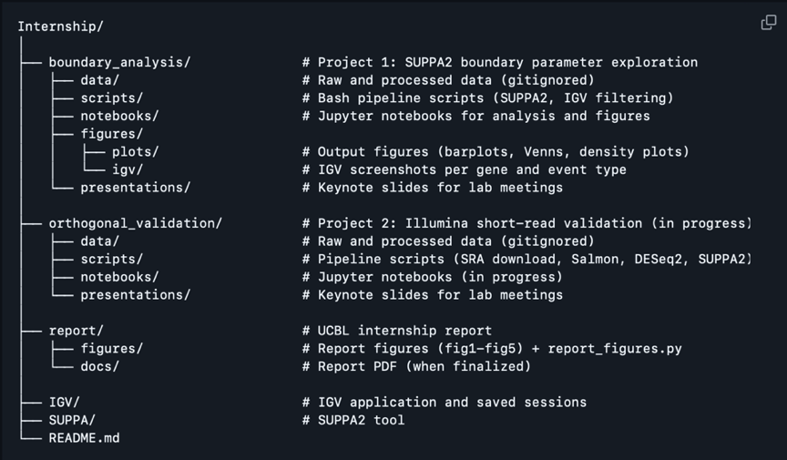
C


Annex C. QR code linking to the internship's GitHub repository (griceyrt/Internship), showing the codebase structure. Raw data and large biological files are excluded via .gitignore.
D
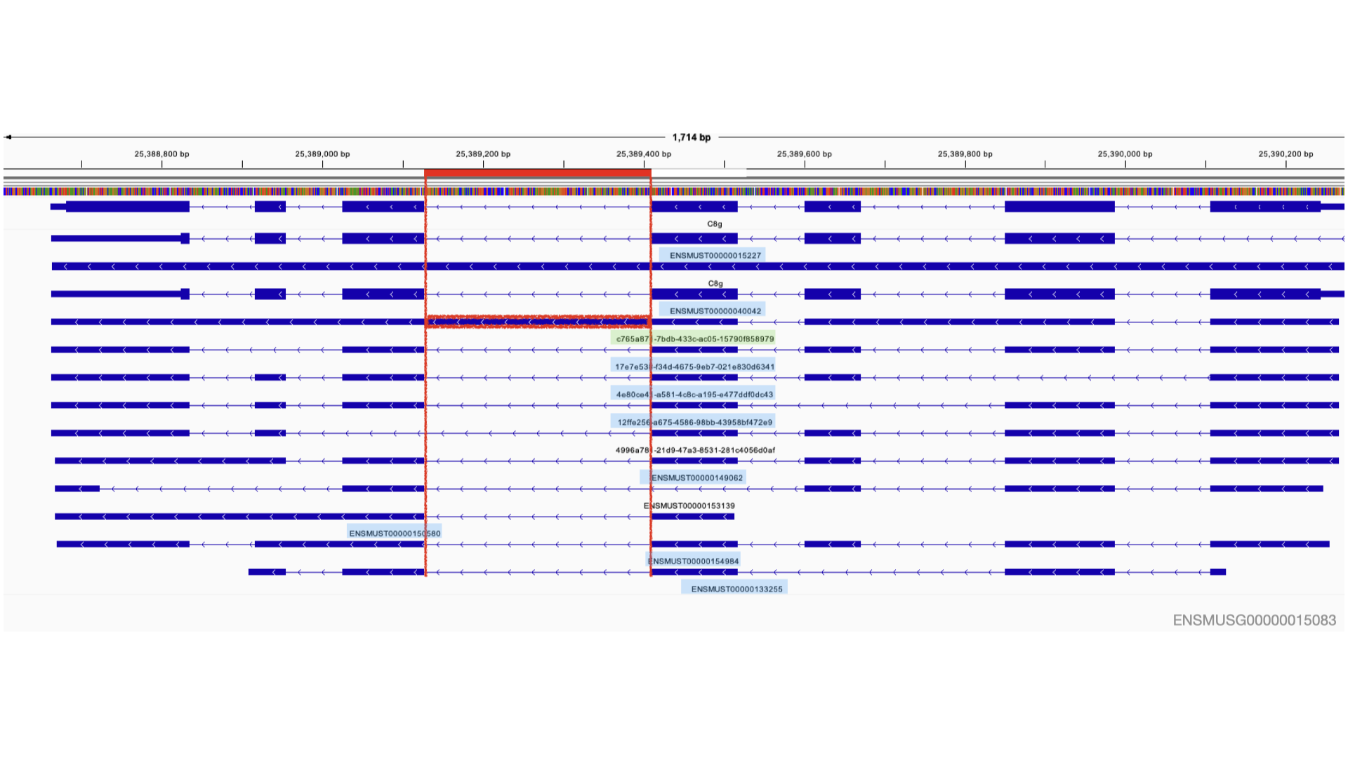
Annex D. IGV visualization of the C8g locus (chr2:25,389,127-25,389,410, variable mode). The red box marks the retained intron region detected only in variable mode. The novel transcript c765a871 (green) drives both the A3 and RI events at this locus. Light blue transcripts are total-only. Gene: ENSMUSG00000015083.
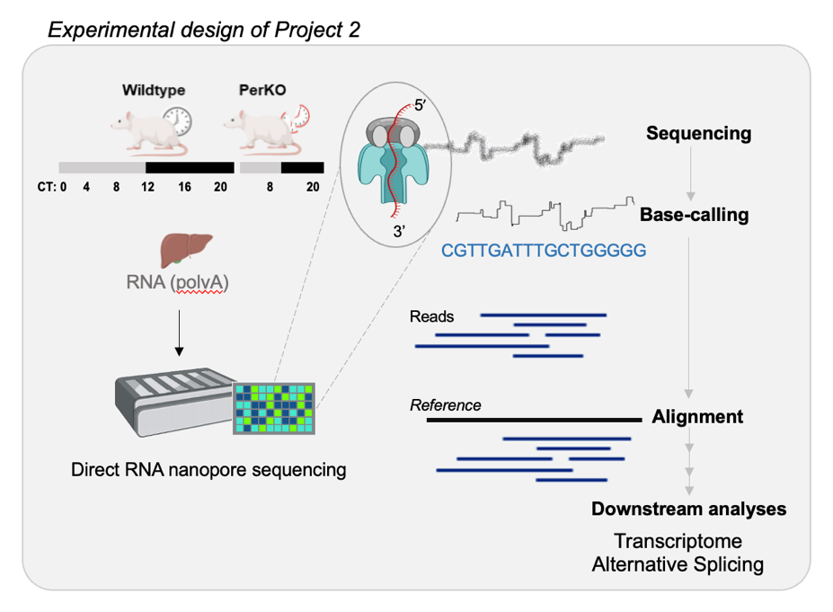
E

Annex E. Experimental design of Project 2.


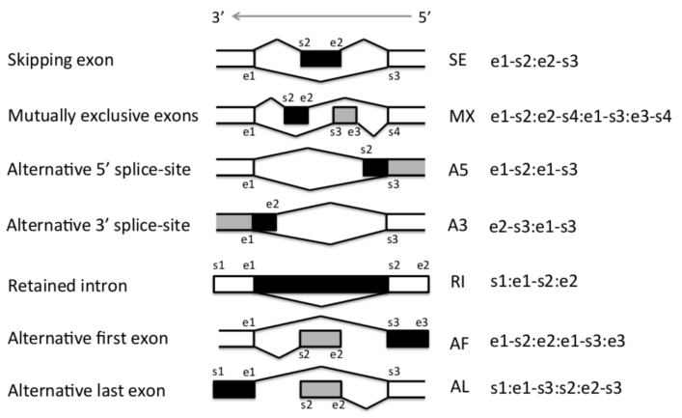
F

Annex F. SUPPA’s nomenclature for events in the forward (left) and reverse (right) strands. Adapted from the SUPPA2 GitHub repository (github.com/comprna/SUPPA).

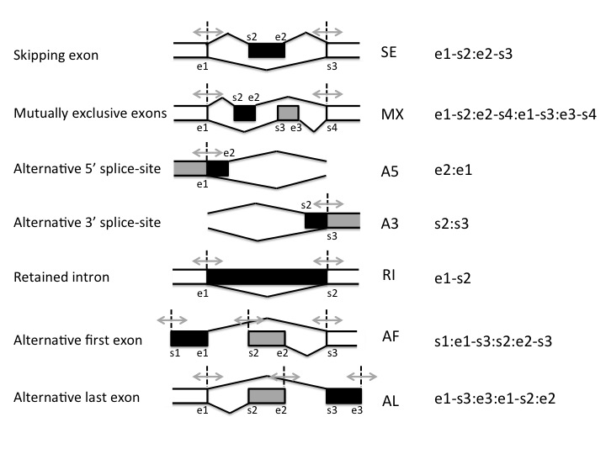
G

Annex G. SUPPA’s nomenclature when variable is used as boundary parameter. Adapted from the SUPPA2 GitHub repository (github.com/comprna/SUPPA).
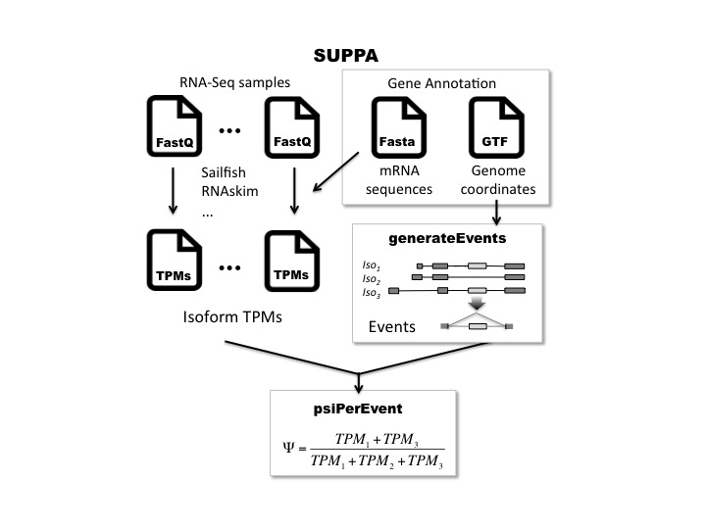
H

Annex H. SUPPA's computational pipeline. Adapted from the SUPPA GitHub repository (github.com/comprna/SUPPA).

